**DAILY ONLINE ACTIVITIES SUMMARY**

|  |  |  |  |  |  |  |
| --- | --- | --- | --- | --- | --- | --- |
| **Date:** | | | **03/06/2020** | **Name:** | **JASLINE SHARON TAURO** | |
| **Sem & Sec** | | | **4th sem, A Section** | **USN:** | **4AL18CS029** | |
| **Online Test Summary** | | | | | | |
| **Subject** | **OBJECT ORIENTED CONCEPTS** | | | | | |
| **Max. Marks** | **30** | | | **Score** | **21** | |
| **Certification Course Summary** | | | | | | |
| **Course** | | | **Python for Machine Learning** | | | |
| **Certificate Provider** | | **Great Learning** | | **Duration:** | | **4 HRS** |
| **Coding Challenges** | | | | | | |
| Problem Statement:  1. Write a code segment in java to swap two numbers using call by object reference. 2. Write a Java program to find Last Digit of a^b (a to the power b) for Large Numbers 3. Write a function that takes a two-digit number and determines if it's the largest of two possible digit swaps. | | | | | | |
| **Status: DONE** | | | | | | |
| **Uploaded the report in GitHub** | | | | **YES** | | |
| **If yes Repository name** | | | | <https://github.com/jaslinesharontauro/JAVA_Prgms>  <https://github.com/jaslinesharontauro/C_Prgms> | | |
| **Uploaded the report in slack** | | | | **YES** | | |

**Online Test Details: (Attach the snapshot and briefly write the report for the same)**

**Certification Course Details: (Attach the snapshot and briefly write the report for the same)**

**Coding Challenges Details: (Attach the snapshot and briefly write the report for the same)**

**1.ONLINE TEST DETAILS:**

**Today we had assessment in the subject OBJECT-ORIENTED CONCEPTS. The test was based on SECOND and THIRD module of this subject. There were total 30 number of questions of ONE mark each, out of which I scored 21.**

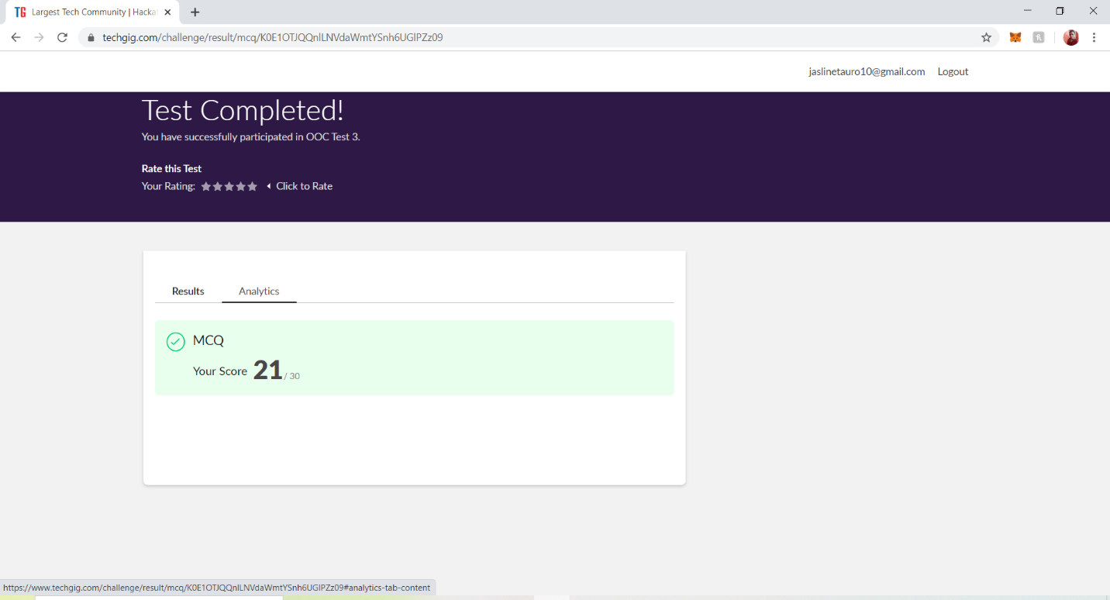

**2.CERTIFICATION COURSE DETAILS**

**Today I have done certification course on Python for Machine Learning Couse by Great learning. Today I learnt about Jupyter notebook shortcuts, Data structures hands on, looping and conditional statements and Introduction to pandas and about series and data frames in pandas. Also, I learnt about accessing and modifying, combining data frames in pandas.**

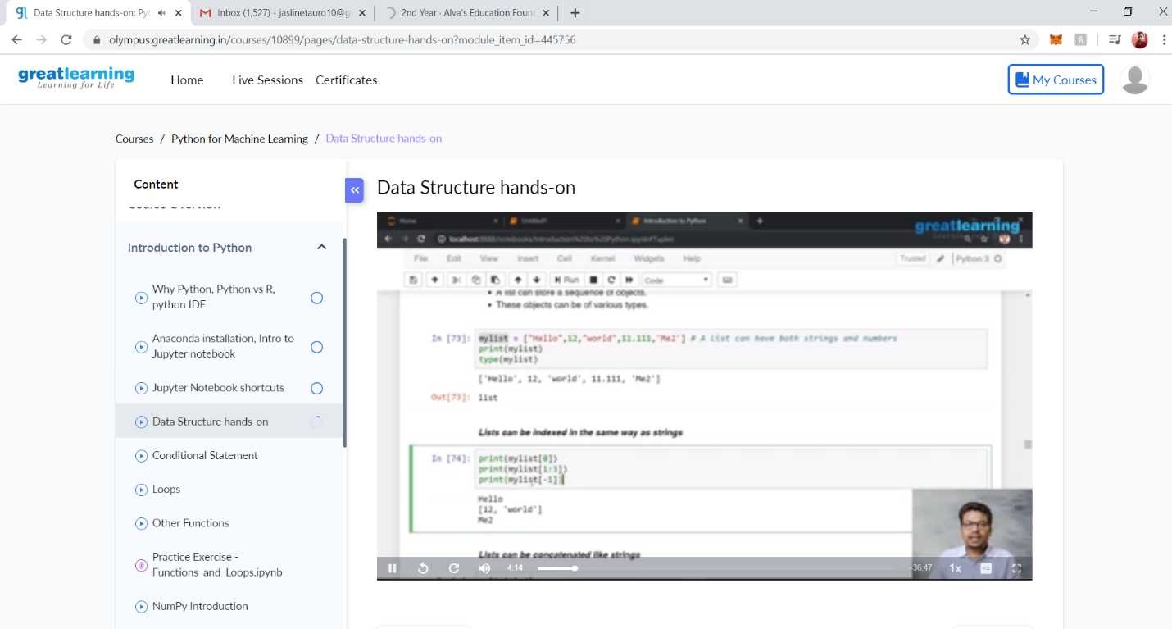

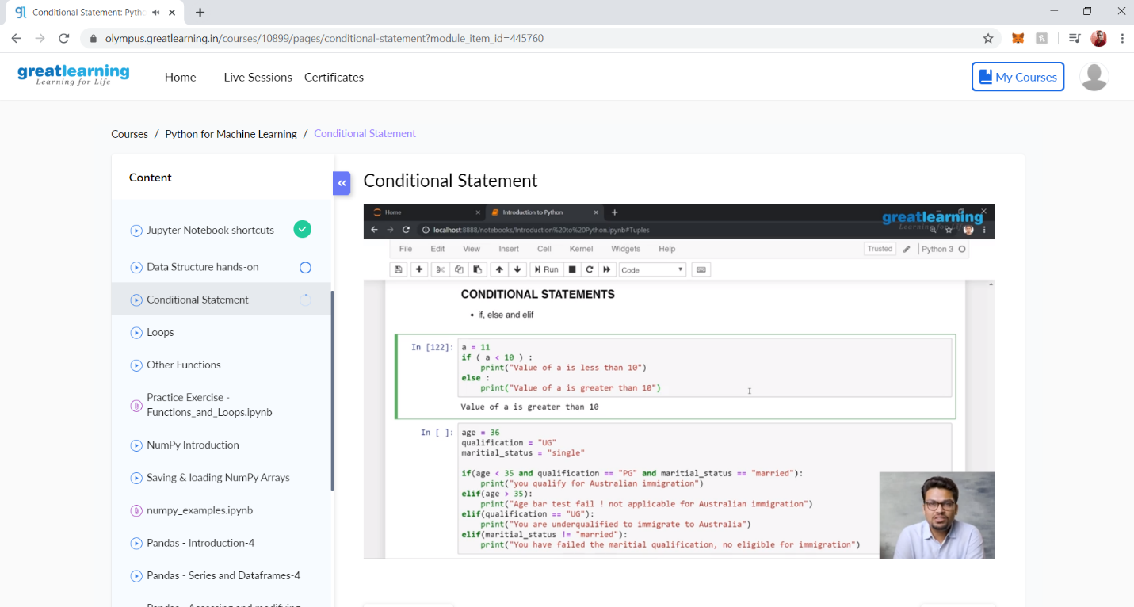

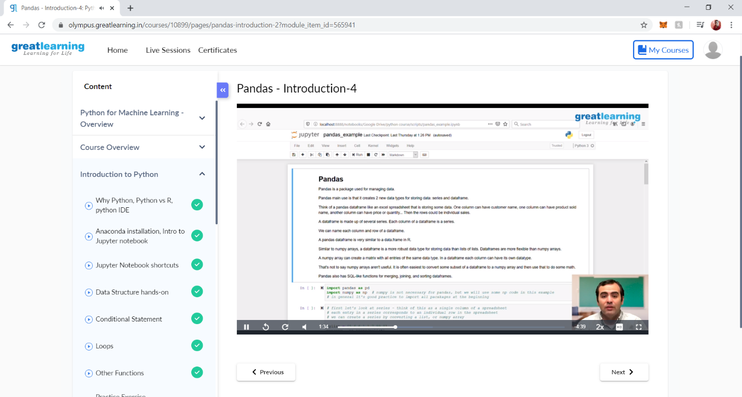

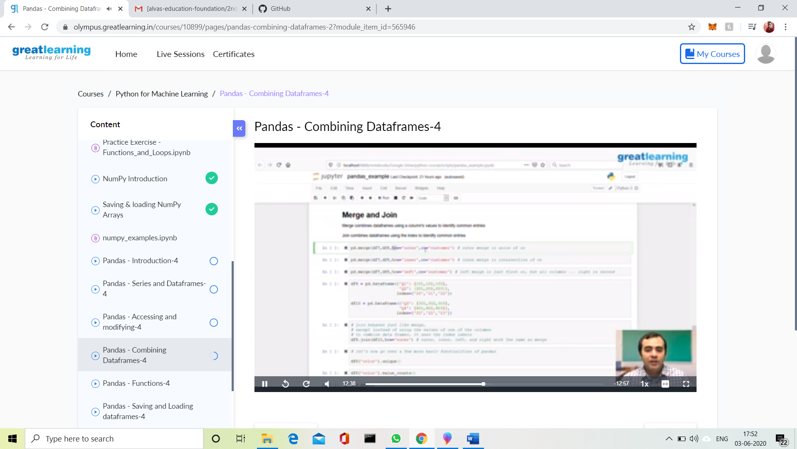

**3.CODING CHALLENGES DETAILS:**

**Problem statement 1:**

Write a code segment in java to swap two numbers using call by object reference.

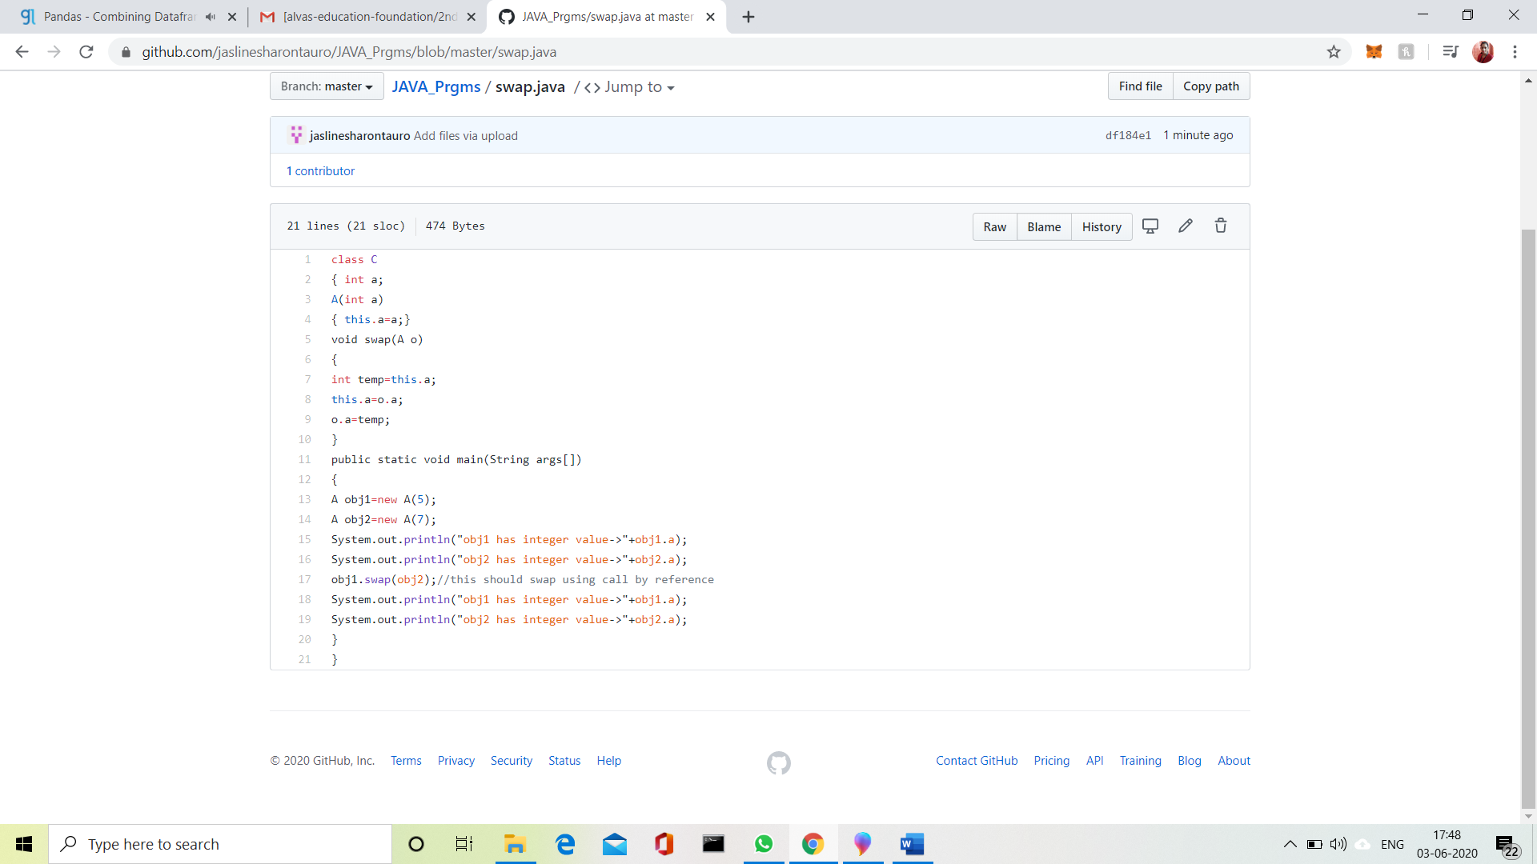

Problem Statement 2:

Write a Java program to find Last Digit of a^b (a to the power b) for Large Numbers

You are given two integer numbers, the base a (number of digits d, such that 1 <= d <= 1000) and the index b (0 <= b <= 922*10^15). You have to find the last digit of a^b.

Examples:

Input: 3 10  
Output: 9

Input: 6 2  
Output: 6  
Algorithm:

1. Since number are very large, we store them as a string.
2. Take last digit in base a.
3. Now calculate b%4. Here b is very large.  
   -> If b%4==0 that means b is completely divisible by 4, so our exponent now will be exp = 4  
   because by multiplying number 4 times, we get the last digit according to cycle table in  
   above diagram.  
   ->If b%4!=0 that means b is not completely divisible by 4, so our exponent now will be  
   exp=b%4 because by multiplying number exponent times, we get the last digit according to  
   cycle table in above diagram.  
   -> Now calculate digit = pow( last_digit_in_base, exp ).  
   ->Last digit of a^b will be ldigit%10.

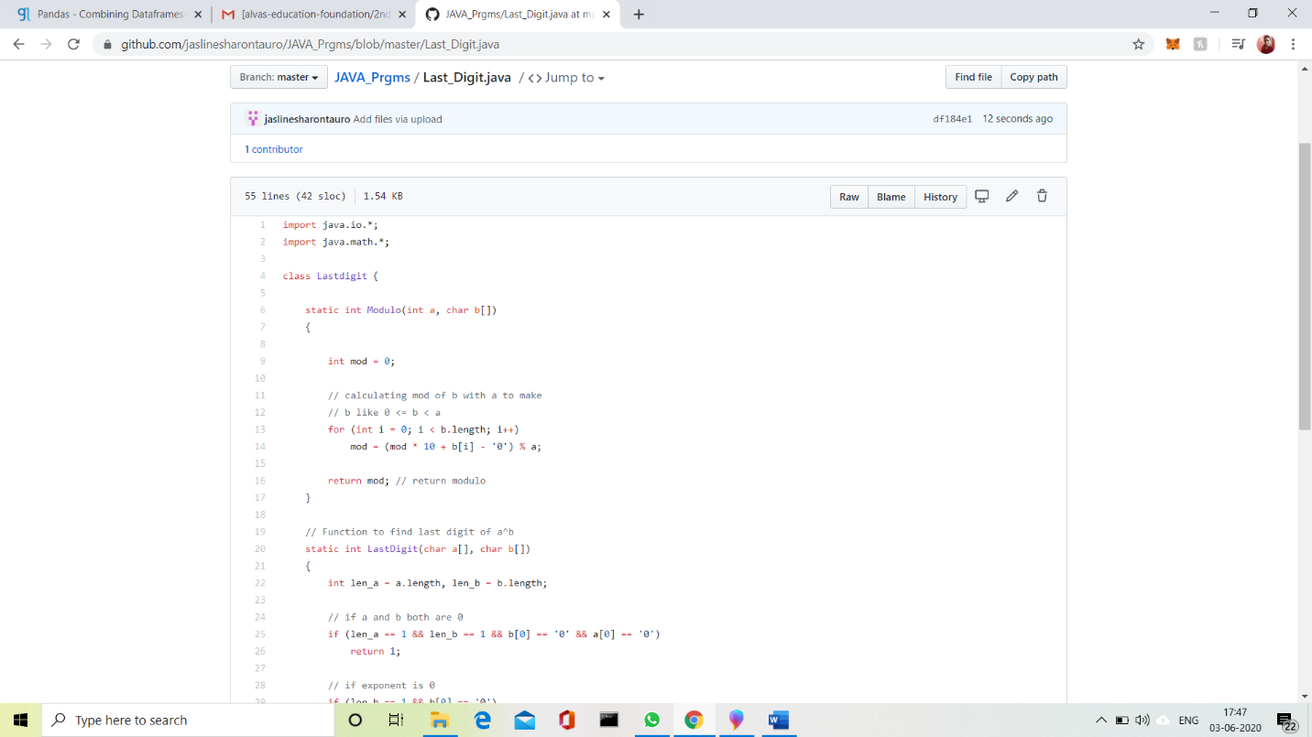

**Problem Statement 3:**

Write a function that takes a two-digit number and determines if it's the largest of two possible digit swaps.

To illustrate: largestSwap(27) ➞ false largestSwap(43) ➞ true If 27 is our input, we should return false because swapping the digits gives us 72, and 72 > 27. On the other hand, swapping 43 gives us 34, and 43 > 34. Examples largestSwap(14) ➞ false largestSwap(53) ➞ true largestSwap(99) ➞ true

